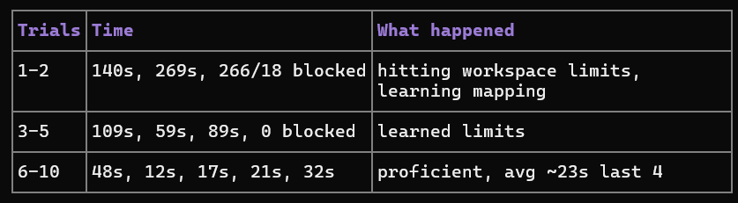
results.csv 94.4% + latency, dataset.csv 99, confusion.png 100% (overfit note), task_results.csv above
Thought · 1.4s
Good — you already have the software side ready (arduino/arm.ino + src/06_serial_control.py). Hardware is just wiring + serial.
1. What you need:
- Arduino Uno + USB
- 4x SG90 + 4-DOF arm frame (or 6-DOF, we use 4)
- 5V 2A supply for servos alone + jumpers
- Laptop with your RoboGrip venv
2. Wire (critical: external power, not Arduino 5V):
Servo signal: base→D9, shoulder→D6, elbow→D5, grip→D3
Servo + → external 5V+, Servo - → external GND + Arduino GND (common!)
Arduino USB → laptop
If arm jitters/resets = power issue, 99% of cases.
3. Upload:
-
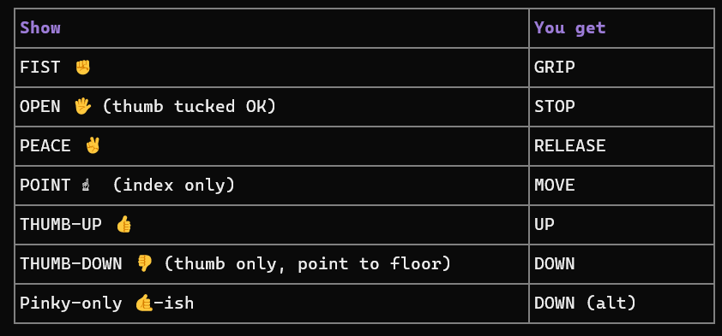

Arduino IDE → open C:\Users\Dell\RoboGrip\arduino\arm.ino → board Uno → Upload. Open Serial Monitor 115200, send GRIP → gripper should close, UP → shoulder +5°.
4. Connect vision:
Set-Location C:\Users\Dell\RoboGrip
C:\Users\Dell\RoboGrip\venv\Scripts\python.exe -m pip install pyserial
# check port in Device Manager → Ports (COM3/COM4...)
C:\Users\Dell\RoboGrip\venv\Scripts\python.exe C:\Users\Dell\RoboGrip\src\06_serial_control.py --port COM3
Hold ✊ → terminal SENT GRIP + servo moves. Same temporal (5, 4/5) + confidence (>0.5) + E-STOP (both OPEN or e, r reset) as virtual, plus Arduino-side limits 20-160/10-150 + BLOCKED ESTOP.
5. Calibrate: if UP goes down, swap +5/-5 in .ino for that joint. Set aGr 40/90 to your gripper’s closed/open.
What arm kit do you have (link/photo)? I’ll map your servo channels + angles exactly — SG90 vs MG996 + 4 vs 6 DOF changes pins/limits.
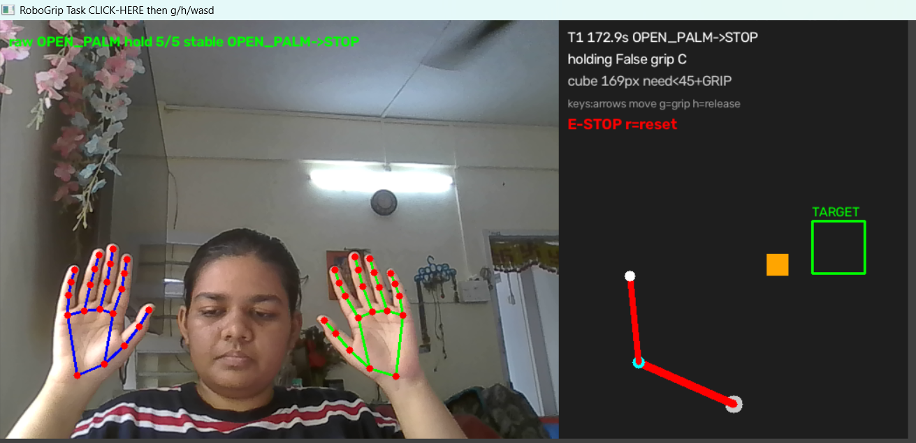
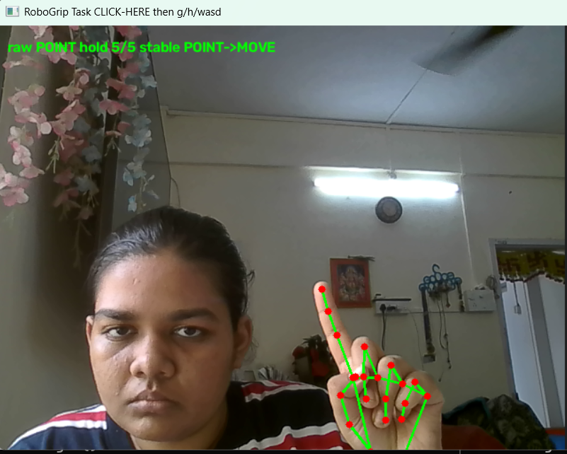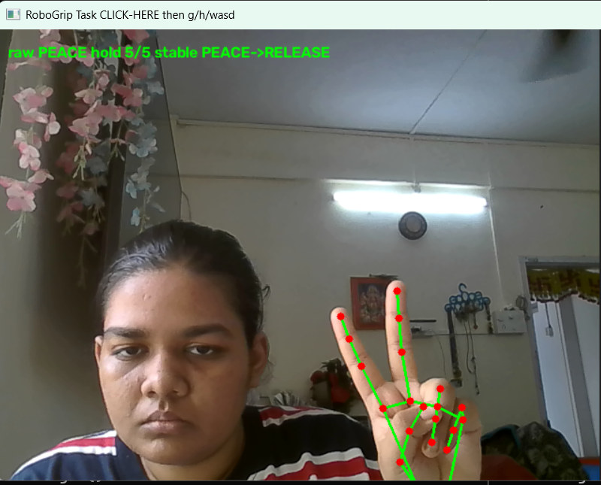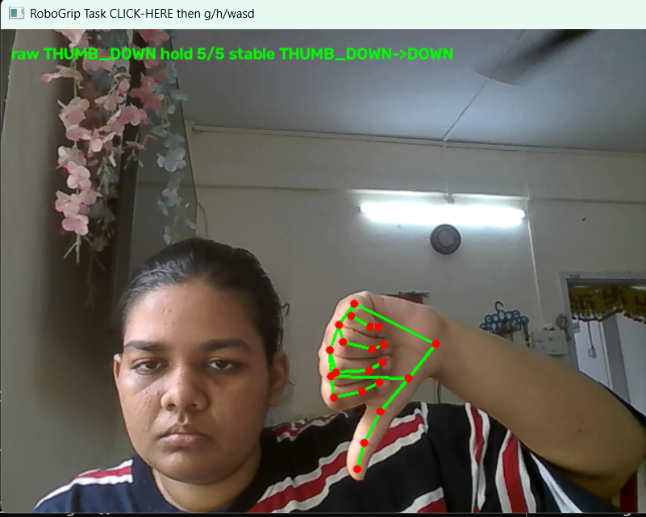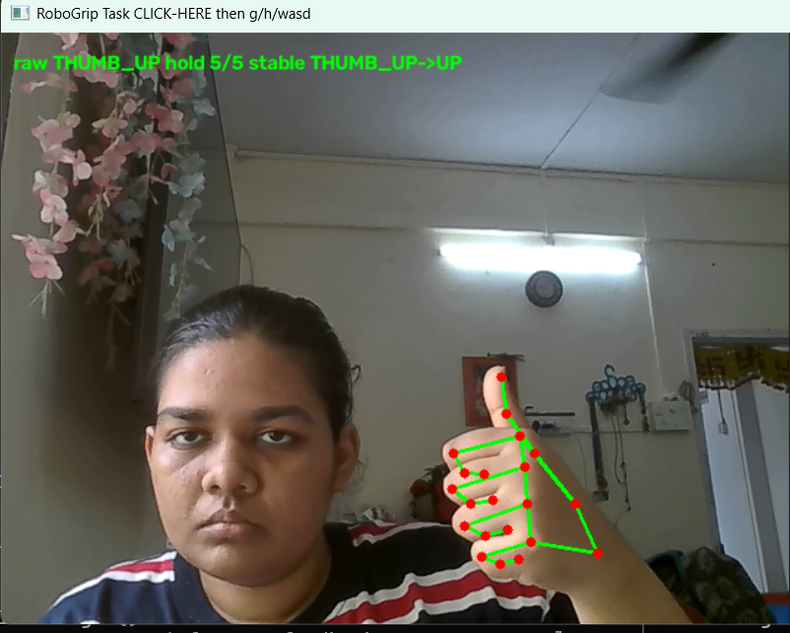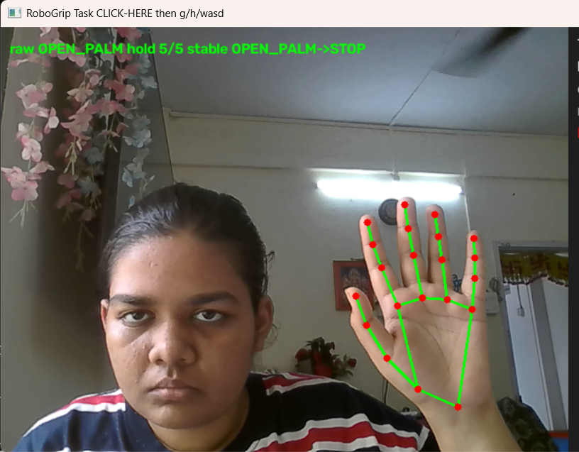
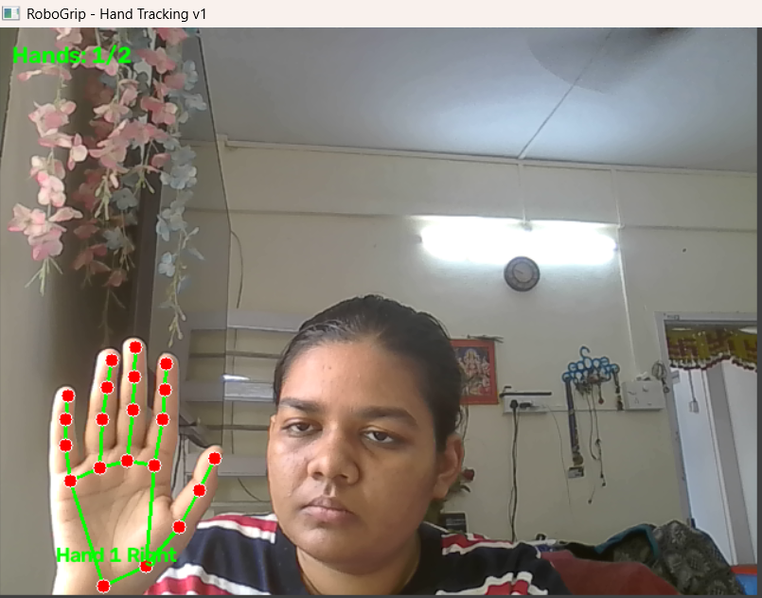

Components required
- USB webcam (Logitech C920 / C270) or depth camera (Intel RealSense D435i)
- Laptop/PC or NVIDIA Jetson Nano/Orin Nano
- Robotic arm kit (Dobot Magician / uArm Swift) or custom-built arm with MG996R servos
- Arduino Uno/Mega or ESP32
- PCA9685 servo driver board
- Regulated power supply (5V–7.4V, multi-amp)
- Emergency-stop push-button/switch
- HC-05 Bluetooth module or Wi-Fi (via ESP32) or USB cable
- Jumper wires
- Breadboard/PCB
- Chassis/mount/3D-printed or acrylic links
- Tripod/camera mount
- LED indicators
- OLED/LCD display
- Python
- OpenCV
- MediaPipe
- scikit-learn / TensorFlow / PyTorch
- PySerial (or MQTT/socket library)
- Arduino IDE / PlatformIO

cd C:\Users\Dell\RoboGrip
.\venv\Scripts\python.exe src\02_hand_tracking.py
. \venv\Scripts\python.exe src\10_task_demo.py

THEORY

